**Preschool education system in foreign countries**

**Yo'ldoshboyeva Parizod Kamoljon qizi**

Foreign language department in preschool

and primary education, 540-20-group student

**Annotation**

In this article, the best practices of preschool education and upbringing in foreign countries are studied on the basis of comparative analysis. Mainly information is provided about the forms of preschool education in developed Western and Eastern countries and the Japanese preschool education system. Also, special attention is paid to the researches conducted in connection with the study of foreign experiences related to preschool education and upbringing. Clear ideas about its methodological basis are stated. The role and importance of the best practices in the education system in ensuring the development of the states is revealed.

**Keywords:** Preschool education system, China, system forms, preschool education service prices, Japanese education system, directive program, educational process.

**Аннотация**

В данной статье на основе сравнительного анализа изучается передовой опыт дошкольного образования и воспитания в зарубежных странах. В основном представлена ​​информация о формах дошкольного образования в развитых странах Запада и Востока и японской системе дошкольного образования. Также особое внимание уделяется исследованиям, проводимым в связи с изучением зарубежного опыта, связанного с дошкольным образованием и воспитанием. Изложены четкие представления о ее методологической основе. Выявлена ​​роль и значение передового опыта в системе образования в обеспечении развития государств.

**Ключевые слова:** Система дошкольного образования, Китай, формы системы, стоимость услуг дошкольного образования, японская система образования, директивная программа, образовательный процесс.

At the same time, in our country, special attention is being paid to the creation of projects aimed at the organization of preschool education and the creation of conditions for quality education in preschool educational institutions. This is related to the implementation of the standard of preschool education, which has become the first stage of education. The federal state standard of preschool education emphasizes the unique value of preschool childhood, the need to create conditions to reveal the potential strengths and opportunities of each child. Therefore, studying and analyzing the development of education abroad is becoming more and more important. Preschool education systems in China and Japan, with their own history and traditions, have great pedagogical potential. For example, the organization of preschool teachers in a Japanese kindergarten is surprising.

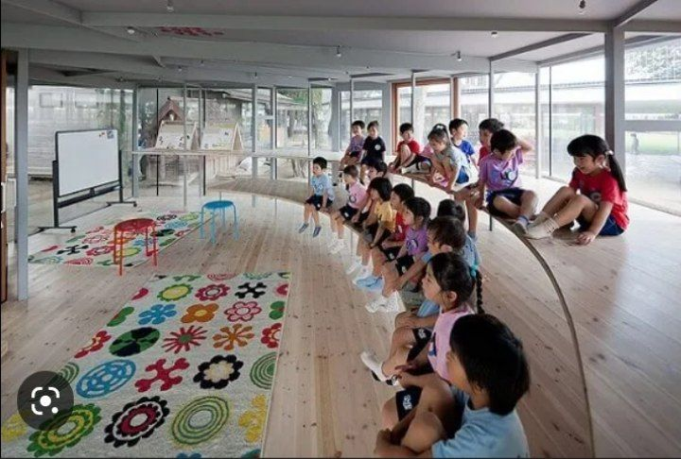

Questions immediately arise: "What methods, methods are used to achieve this?" The purpose of the work: to analyze the system of preschool education in China and Japan. The work consists of an introduction, two chapters, a conclusion and a list of used literature. 1. Peculiarities of the preschool education system in China Today, preschool education institutions in China include: - preschool education institutions of the state model, that is, kindergartens established by the initiative of the Ministry of Education; - private kindergartens organized by residents; - departmental pre-school educational institutions jointly financed by the state and enterprises. However, there are other forms of preschool education. - kindergartens - they accept children older than 1 year and under 3 years; - combined kindergartens - they are opened by large enterprises. Children of employees from 4 months to 6 years old are brought up in these institutions.

They work day and night; - preschool education groups - usually the kindergarten itself opens a school preparation group. The school and some other organizations (for example, "Childhood Palace") also have the right to open a preschool group. The creation of changing forms of pre-school education through the establishment of kindergartens for young children remains a priority; general development, compensatory, remedial, combined orientation groups in kindergartens of various types; short-term joint groups of children and parents opened on the basis of kindergartens, additional educational institutions (children's play support centers, adaptation groups). Creation of changing forms of pre-school education remains a priority; general development, compensatory, remedial, combined orientation groups in kindergartens of various types; short-term joint groups of children and parents opened on the basis of kindergartens, additional educational institutions (children's play support centers, adaptation groups). Early childhood education and training is compulsory in China. Usually, children are admitted to Chinese kindergartens from the age of 3 and up to the age of 6. There are age groups: small, medium, large. Groups in kindergartens are quite large, up to 25 children in a small group, up to 30 in a medium group, and up to 35 in a large group. Each group has a period of 1 year. Each group has two specially trained and certified educators and one assistant educator.

Upon admission to the kindergarten, the child receives a uniform and a backpack of the same style as for all children. It is not necessary to wear such things, but often children choose them, and parents do not have to look for some new clothes, and one uniform creates a sense of belonging to the team. Agenda: After the flag-raising ceremony at 7.40, the teachers will conduct morning exercises with the children in the street, to the cheerful marching music. Then the guys go to breakfast. Classes are held from 8.30 to 10.00. The favorite pastime of all children is artistic creation. Special attention is paid to the preparation of crafts from improvised materials. Music and dance are performed directly in the group, and sports are performed on the street. After lunch, it's time to sleep - from 12.00 to 14.30. The working day in kindergarten ends at 17:00, part of it stays at night; parents pick them up only on wednesday and saturday.

Most of the children stay for additional activities, paid "clubs". Among these activities - drawing, Chinese gymnastics, skating, ballroom dancing. The fee for these classes varies from 60 to 300 Chinese yuan (about 240 to 1200 rubles) per month. The monthly fee for keeping a child in a state preschool educational institution is 730 yuan (about 3000 rubles) per month. The cost of going to a commercial kindergarten can be 2 times higher. Apart from paying for tuition, clothes and heating, parents do not require any additional expenses. This is strictly monitored by the anti-corruption committee and an information letter is sent to all parents every 6 months. In it, the committee asks to inform the cashier of the kindergarten about the cases of additional payments.

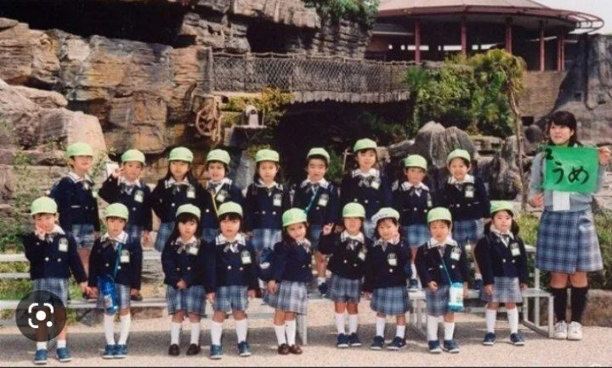

Kindergarten time ends with a big concert dedicated to children's achievements. Children sing, dance and show what hieroglyphs they have learned, what toys they have learned to make with their own hands. Kindergarten education is not compulsory in China, but all preschools have preschool programs. Currently, all pre-school educational institutions work according to a single program of education and training - Pre-School Education Directive Program (experimental version). This program (2001) was approved by the Ministry of Education of the People's Republic of China and is based on the theories of L.S. Vygotsky, J. Piaget, G. Gardner and the Chinese teacher Dao Xizhi.

The program consists of five sections: Health (health care, teaching the basics (rules and habits) of a healthy lifestyle); Speech (increasing communicative activity, developing speech skills); Social skills (developing self-esteem, self-confidence, caring for others and establishing friendly relations with them, helping the development of the individual in general); Scientific interests (awaken interest and desire to learn, develop cognitive abilities); Art (the desire to form aesthetic feelings, develop emotional sensitivity and create beauty). Kindergarten education is divided into two stages, each lasting six months. When working with children, collective forms of classes prevail, all lessons and games are held together with the mandatory participation of all children. Toddlers are taught math and reading.

Children learn to write hieroglyphs: by the first grade, a little Chinese should know about four hundred characters. State and non-state institutions differ with a single approach to education and upbringing of preschool children: in state kindergartens, children are taught to work, prepare for school, and engage in minimal aesthetic impressions and knowledge in the field of culture. . The knowledge gained by the children is very practical. Children are taught to understand nature and natural phenomena. Each group has its own kindergarten. Children will learn how to care for plants, how to make pots grown with their own hands. Great attention is paid to personal hygiene and cleanliness. In private parks, more attention is paid to the cultural and aesthetic development of children, for which parents have to pay extra. In general, Chinese kindergarten is not only useful activities, good food and games.

This is also an extremely strict discipline, respect for elders. Kindergartens have a principle: children should stop being selfish. Quarrels, bad behavior, corruption, disobedience to the elder's request are not allowed here. It is necessary to immediately intervene in children's quarrels: otherwise, it is believed that the child's behavior will be accepted and will retain a bad character for life. But there is no punishment: it is not allowed to beat or take the child out of the room. In the classroom, children are passive, submissive to the will of adults, subject to discipline - in China, this is considered a manifestation of care and attention to them. Every week, the child's behavior and knowledge are evaluated on a 100-point scale. The table with the results is placed on the stand for all parents.So, in general, the day of a Chinese preschool teacher is similar to the same day of a Russian child. The distinctive features of the learning process that characterize preschool education in China are as follows. - morning in kindergarten - time to raise the flag. Love and pride for the country is cultivated from preschool age; - getting used to work consists in the presence of gardens in educational institutions where children of preschool age learn to grow vegetables. And sometimes they are even baked; - children's games are subject to strict discipline, free time is idle time, and this does not exist in China. In Chinese preschools, the school day is planned almost to the minute. The main task is to load the children, to fully occupy them. In a Chinese kindergarten, there is no free time for the teacher and the children. In China, free time is equated with idleness, it is considered aimless.

The Chinese preschool education system is often characterized by its strictness, strict regulation of children's behavior and games, strict discipline, control that does not allow the child to even think that he is special. is criticized for being combined with But for the Chinese, the rule "what is good for the state is good for the people" is an inviolable rule. 2. Features of the Japanese preschool education system Kindergarten is not a compulsory level of education in Japan. Children come here at the request of their parents. In Japan, pre-school education is provided as follows: kindergartens, children's centers; kindergartens. Kindergarten (children's center) in Japan can place a child from three months of age and only to working parents. But in order to place a child in such an institution, parents must write a special application and justify with very good reasons that it is impossible to raise the baby at home for up to three years.

The fact is that this is contrary to the principle of family upbringing on which the entire Japanese culture is based. Kindergartens are designed to look after children and do not provide educational programs, therefore, like all educational institutions, they are not under the Ministry of Education, Culture, Sports, Science and Technology, but under the Ministry of Health, Labor and subordinate to the Ministry of Welfare.

The issue of placing a child in a pre-school educational institution is decided by the municipality, regardless of the type of institution (public or private). By applying to the administration, parents will receive an atlas of kindergartens (kindergartens) with information on the number of places in a preschool educational institution. In the past, parents can visit the kindergarten, talk to the staff and choose the kindergarten they like, but the final word remains with the municipality, if there are vacancies, the parent will choose the kindergarten. gets permission to enroll in chasi (green). The preschool education system in Japan includes the following types of institutions: state, prefecture, city; private; kindergartens in schools and universities - if a child enters such a kindergarten, his future can be considered safe: he reaches the appropriate age, goes to a university school, and from there he enters the university without exams.

More than 80% of the pre-school education system in Japan is private kindergartens and kindergartens. In Japan, there is not much difference between public and private preschool education. According to the basic law "On Education" adopted in 2006, the system and approach of the educational process is based on the same principles. The payment for keeping a child in a public or private kindergarten depends only on the income of the parents - the higher the family's income, the higher the kindergarten fee. The average fee ranges from $100 for low-income families to $500 for wealthy families. The age of the child is also important for kindergartens (care centers), the younger the child, the higher the price. But even so, the fee for a private garden is higher and includes an entrance fee that can reach up to $1,000 in addition to the monthly fee.

In addition, you will have to pay the form, which is mandatory in all kindergartens. Each kindergarten has its own uniform: the same pants, skirts, blouses, shirts, hats and bags. Uniform is mandatory. You can place a child in a kindergarten at any time of the year, but there are many such places from April 1. This is because the school year in Japan also starts on April 1, and some preschoolers go to elementary school. On this day, a solemn opening ceremony will be held in all educational institutions - from kindergarten to university. The director of the kindergarten greets the children with the same seriousness as the rector of the university - his students.

Kindergarten is usually accepted from the age of four. Sometimes, as an exception, when parents are too busy, a child can be taken to kindergarten from the age of three. The duration of preschool education is 3 years, after which the child enters primary school. The quality of education and service for a child in a pre-school educational institution largely depends not on a private or public kindergarten, but on a particular kindergarten, its location and pedagogical staff. The employment of the groups is also very different and ranges from 8 to 30-40 people. The working hours of preschools in Japan are different, for example, there are two types of public kindergartens: full-day kindergarten, the working hours of such kindergartens are daytime + Saturday (part-time). In such a kindergarten, a child can be admitted if both parents work more than 4 hours a day.

As a rule, the morning in the parks starts at 8 o'clock, you can pick up the child at any time until 5 o'clock, for an additional fee, the child can be looked after until 7 o'clock. evening And the second type of kindergarten, kindergarten, accepts children for half a day. All educational institutions of the country work on the basis of a single schedule: the academic year is divided into three semesters. Between semesters - vacations for students, schoolchildren and kindergarteners: summer vacation from July 21 to August 31, winter vacation from December 21 to January 8, spring vacation from March 21 to April 1. On weekends, small children can come to the kindergarten to swim in the pool (almost every kindergarten has a pool) and talk a little about life with the teacher. But there are no lessons. Preschool education institutions in Japan have the following tasks: - to help the child to establish good relationships with adults and children, to acquire social behavior skills; - development of respect for nature; - help to acquire healthy lifestyle skills; - helping parents to raise a child who is intact and able to cooperate with other children; - providing equal conditions for all children; - education of patience and perseverance; - develop the ability to depend on others and understand them.The involvement of parents in the educational process is very high in kindergartens. In Japan, the constant participation and active participation of parents in the process of raising children is required. A child without parents is not more than two, maximum four hours. At the same time, education is carried out not only for children, but also for parents. In the kindergarten, the practice of keeping a notebook is carried out, in which the teacher notes about the child's activities during the day: how he slept, ate, how he felt, etc., and the parents are also expected to answer. Teachers and parents record interesting observations and their thoughts about the upbringing of a particular child. The entire process of raising children is based on the close cooperation of teachers and parents.

Pedagogical foundations of the formation of children's personality formed in kindergarten and school allow the teacher at school to spend almost no time on applying discipline and organizing the behavior of students - all time and attention is focused on mastering children. new knowledge. This phenomenon of Japanese preschool education has already found scientific confirmation in pedagogy: it has been proven that children learn the rules better when they receive the least external coercion in the process of learning the rules. For all the positive aspects of raising children in Japan, it is widely believed outside the country that Japanese people are too indoctrinated with a sense of collectivism, which destroys their individuality. Conclusion In this article, we examine the characteristics of preschool education in China and Japan. In conclusion, let's briefly emphasize the following. Kindergartens in China are divided into public and private.

All kindergartens work according to the uniform preschool education program approved by the Ministry of Education. At the same time, in the state - preparing children for school and work education is a priority, and then private preschool educational institutions specialize in aesthetic, cultural and personality-oriented education. In Chinese preschools, the school day is planned almost to the minute. In China, free time is equated with idleness. Great attention is paid to personal hygiene and cleanliness. Children are taught to work actively. A lot of the knowledge that children learn in the garden can be put into practice, for example, they plant and care for plants. Attending preschool in Japan is neither necessary nor compulsory. Most kindergartens are private organizations, the number of public kindergartens is small. In order for the child to enter the garden, parents must provide serious evidence to the authorities.

The main feature of education in Japan is strict and unquestioning adherence to established traditions and established lifestyles. Groups in preschools are small, with five to six children. The composition of groups and caregivers changes every six months to develop the communication and communication skills of a young child. The purpose of studying in a Japanese garden is more educational than educational. The analysis showed that each system has its own characteristics, pluses and minuses, non-standard approaches to raising children. In both China and Japan, the main goal of the preschool education system is the socialization of the child.

**References and Websites:**

**1.**Lisin, Ch. Features of the organization of preschool education in China [Text] / Ch. Lisin // Preschool education. - 2009. - No. 12. - P. 95-104.

**2.**. Paramonova, L. For knowledge - around the world. Preschool education in Japan [Text] / L. Paramonova, E. Protasova // Preschool education. - 2010. - No. 3.

**3**. Petinenko, I.A. Japan's education system: what makes this country successful? [Text] / I.A. Petinenko, A.A. Weaver // Bulletin of Tomsk State University. - 2012. - No. 2 (18). - S. 175-178.

**4**. Sazonova, D.S. Preschool education systems abroad: their pedagogical potential [Text] / D.S. Sazonova, V.A. Zebzeeva // Society and civilization in the 21st century: trends and development prospects. - 2014. - No. 8-12. - S. 161-166.

**5**. Xiaoyuan, M. Management of preschool education in China and Russia: Curriculum and methodological guide [Text] / M. Xiaoyuan, V.F. Gabdulkhakov. - Kazan: Kazan (Volga Region) Federal University, 2014. - 119 p. 6. Zong, Ch. Ts.

**6.**Preschool education in China: the experience of development of the educational system [Text] / Ch.Ts. Zong // Modern problems of science and education. - 2015. - Issue 1-1. Located on Allbest.ru

**7.**Read more at: https://minikar.ru/uz/moda-i-krasota/doshkolnoe-obrazovanie-yaponii-harakteristika-sistemy-doshkolnogo/